Experiment No.:
Student Name: Aman UID:25BIT10145
Branch: Computer Science & Engineering Section/Group:25BDS115-A
Semester:2 Date of Performance:
Subject Name: Emerging & Disruptive Technologies Workshop
Subject Code: 25ECP-103

1. Aim of the Experiment: Introduction to open-source IoT Platform and basic interfacing Hands-on.

2. Tools/ Hardware Components/Software Used: Arduino IDE, ESP32 Microcontroller, LED, Resistor, connecting Wires and Breadboard.

3. Theory: Open-source IoT (Internet of Things) refers to the use of open-source software and hardware technologies in the development of IoT solutions. In this context, "open-source" means that the source code and design specifications of the software and hardware components are freely available for anyone to view, use, modify, and distribute.
Open-source hardware platforms like Arduino with WiFi module, ESP 32 and many more, which provide a foundation for building IoT devices and prototypes. Arduino Uno.
Whereas, an open-source IoT (Internet of Things) platform is a software framework that enables the management, monitoring, and control of IoT devices and data in a collaborative and transparent manner. These platforms are built upon open-source technologies, allowing developers to access, modify, and distribute the source code freely. Popular examples of open-source IoT platforms include:
- Eclipse IoT
- ThingSpeak
- OpenIoT
- Kaa IoT Platform
Components Needed:
- ESP32 development board (e.g., ESP32 DevKit)
- LED
- Resistor (220 ohms)
- Jumper wires
Circuit Setup:
- Connect the positive (longer) leg of the LED to GPIO pin 2 of the ESP32.
- Connect the negative (shorter) leg of the LED to a current-limiting resistor (220 ohms).
- Connect the other end of the resistor to the ground (GND) pin of the ESP32

4. Code/Circuit Diagram/Procedure:
Program Code:

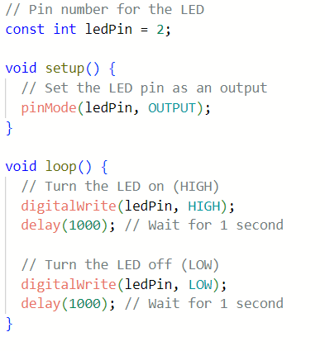

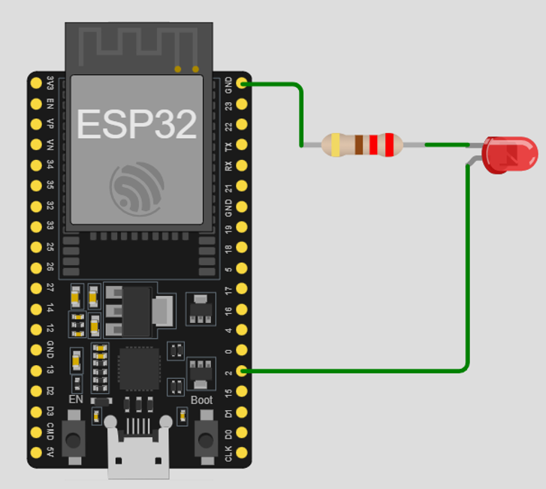

5. Observations, Simulation Screen Shots, and Discussions:
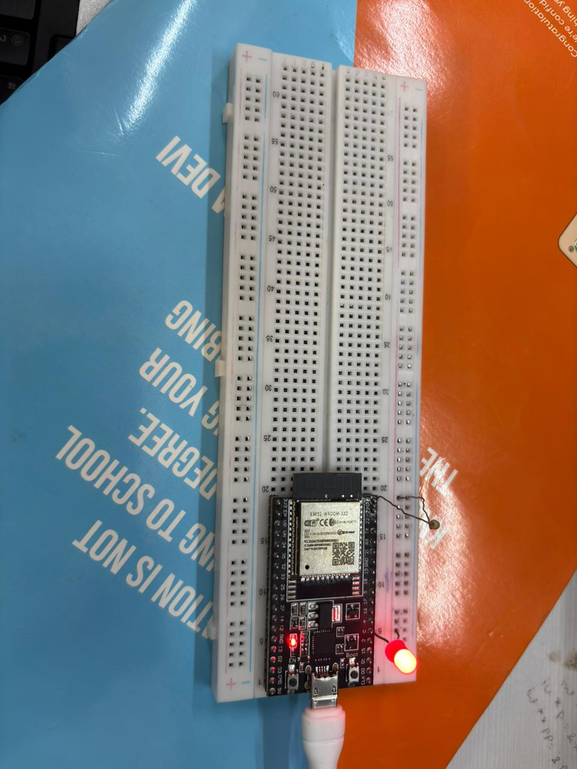

6. Result and Summary: the led was blinking after the certain time that was mentioned

In the code .

7. Additional Creative Inputs (If Any):
Learning outcomes (What I have learnt):
1.to learn about how esp-32 works
2. to learn how Arduino Uno.
3.
4.
5.

